SmartCare v0.3 - Domain Model Workbook
Week 6 student resource

Requirement-to-Concept Trace
Requirement | Concept | State/behaviour | Decision
Create appointments | Patient | Create | Include
Store appointments | Clinic | Store | Include
Retrieve appointments | Clinic | Retrieve | Include
View appointments | Practitioner | View | Include
Sort appointments | Staff Member | Sort | Include
Delete appointments | Patient | Delete | Include
Edit appointments | Patient | Edit | Include
Search appointments | Staff Member | Search | Include

CRC Cards

Patient
Responsibilities | Collaborators
Check if they have an appointment scheduled | Practitioner
Check if they are available for an appointment | Appointment

Practitioner
Responsibilities | Collaborators
Check if they have an appointment scheduled | Patient
Check if they are available for an appointment at a certain time | Appointment

Appointment
Responsibilities | Collaborators
Check if patient and practitioner are available | Patient
Calculate appointment cost (if any) | Practitioner

Optional class
Responsibilities | Collaborators

UML Class Diagram
Insert/draw UML here. Include defensible relationships and multiplicities.
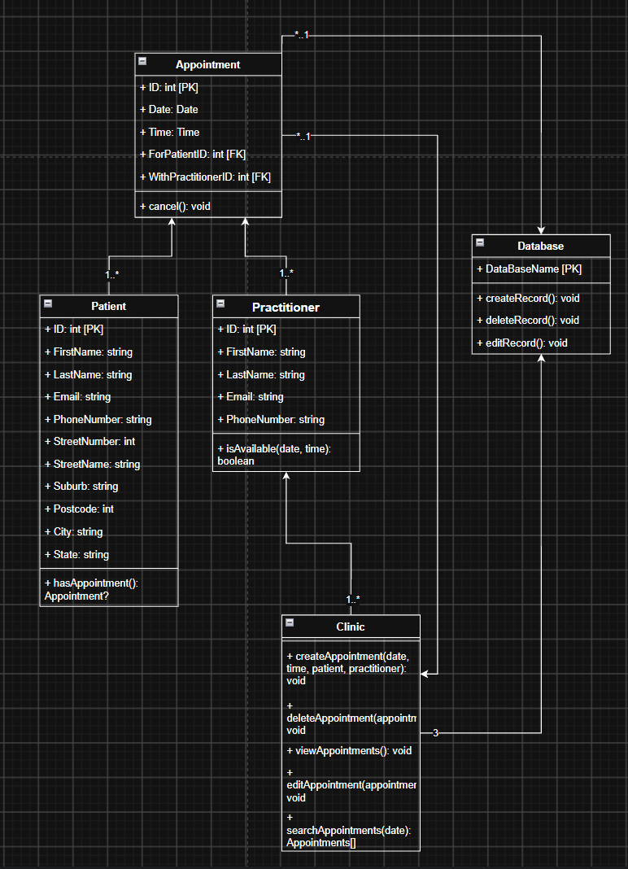

Design Rationale
Explain class selection, responsibility allocation and key relationships.

AI Design Review Record
AI suggestion | Evidence | Decision | Reason | Model change

